Decision tree simplified

Consider an example where we want to predict whether a person is fit or not. We have the age of a person and along with the age, we have two more features as whether that person eat’s a lot of pizzas and does he/she exercise in the morning? After training the model, we got below tree:

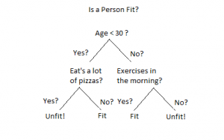

So, as per our model, if the age of the person is less than 30 and they do not eat a lot of pizzas, they are fit. Similarly, if they are above 30 and exercises in the morning, they are fit. In all other scenarios, the model will predict that the person is unfit.

Let’s consider a new person comes to test whether he is fit or unfit. Following are the information about that person:

Age : 32
Eat’s a lot of pizzas : No
Exercises in the morning? : Yes

Now, let’s understand how the model will work in such case and predict whether the person is fit or unfit. We will start from the top of the above tree. As the age of the person is 32, i.e. >30, we will go to the right side of the tree. Now the model will ask whether the person exercises in the morning. From the above information, it turns out that the person exercises in the morning and hence the model will predict that the person is Fit.

This is how a decision tree makes decision based on the conditions.

